**Design Phase Report**

**Category: Application Development Project**

**Title: Appliance Store Management system**

**List of Team Members:**

|  |  |  |
| --- | --- | --- |
| **Roll number** | **USN** | **Name** |
| 43 | 01FE18BCS043 | Anusha Raikar |
| 44 | 01FE18BCS044 | Apoorva Jinde |
| 45 | 01FE18BCS045 | Archana Badagi |
| 54 | 01FE18BCS054 | Ashwini Banagar |

**Team Leader:** Apoorva Jinde

**Responsibilities:**

**Anusha Raikar:**

Tables’ creation, insertion of values and Normalization

**Apoorva Jinde:**

GUI implementation and Normalization

**Archana Badagi:**

Data collection and Normalized Schema

**Ashwini Banagar:**

Normalized schema and ppt.

**Requirements Specification:**

1. Details about price of the product,Employees,Suppliers.

2.Bill geneartion

3. Details about Customer and their Accounts.

4. Proper security of all data.

**ER Design:**

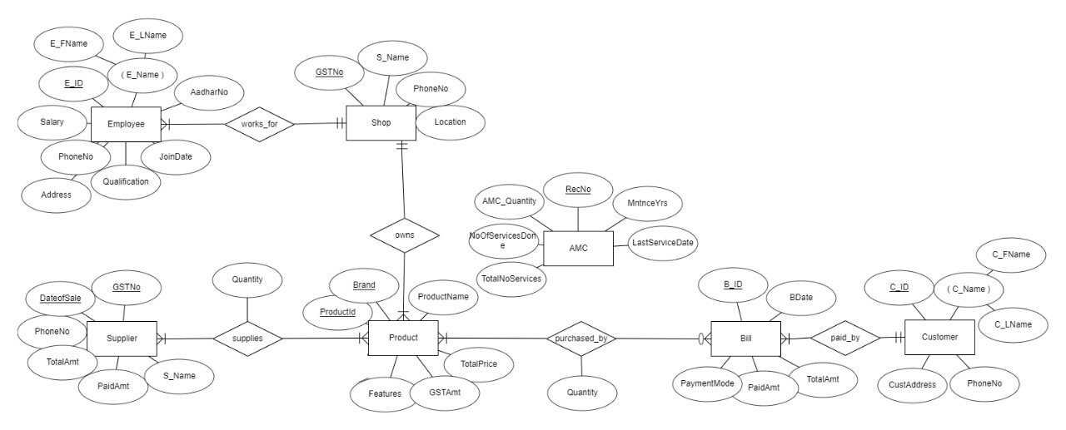

**ER to Relation Mapping:**

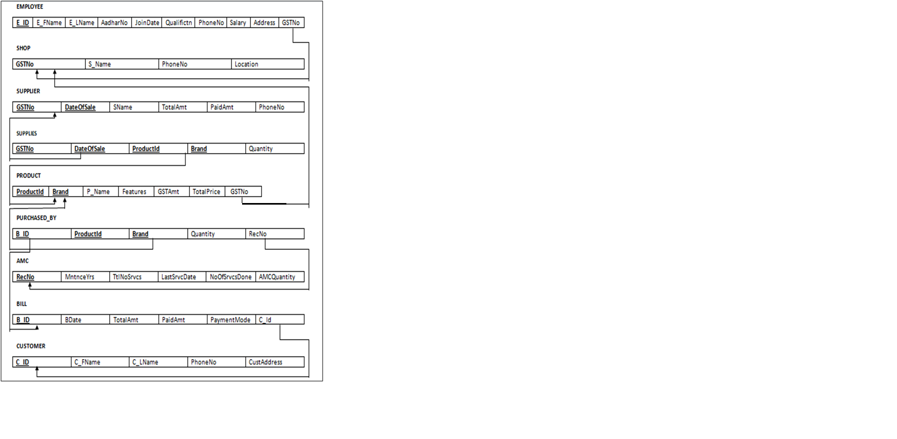

**Data Dictionary**

|  |  |  |  |  |  |
| --- | --- | --- | --- | --- | --- |
| **Object (Entity)** | **Name (Attribute)** | **Type**  **(Data type)** | **Description** | **Primary Key** | **Foreign Key** |
| Shop | GST_NO | String | Unique identification number for the Shop. | Yes | No |
|  | S_Name | String | Name of the Shop | No | No |
|  | Location | String | Location/Address of the Shop | No | No |
|  | PhoneNo | Integer | Phone number of the Shop | No | No |
| Employee | EmpId | String | Unique identification for each employee | Yes | No |
|  | FName | String | First name of the employee | No | No |
|  | LName | String | Last name of the employee | No | No |
|  | Salary | Integer | Salary of the employee | No | No |
|  | Qualification | String | Qualification of the employee | No | No |
|  | PhoneNo | Integer | Phone number of the employee | No | No |
|  | Address | String | Address of the employee | No | No |
|  | JoinDate | Date | Date on which Employee joined | No | No |
|  | AadharNo | Integer | Unique Aadhar number of the Employee | No | No |
|  | GSTNo | String | GSTnumber of the shop | No | Yes |
| Customer | CustId | String | Unique identification number for the customer. | Yes | No |
|  | C_FName | String | First name of the customer | No | No |
|  | C_LNname | String | Last name of the customer | No | No |
|  | PhoneNo | Integer | Phone number of the customer | No | No |
|  | CustAddress | String | Address of the customer | No | No |
| Product | ProductId | String | Unique id for the product | Yes | No |
|  | Brand | String | Name of the company brand the product belong to | Yes | No |
|  | ProductName | String | Name of the product | No | No |
|  | TotalQuantity | Integer | Total number of products of particular type | No | No |
|  | GSTAmt | Integer | It is the GST amount the product of this brand holds | No | No |
|  | TotalPrice | Integer | Amount Price of the product plus the GST amount which is the total price of that particular product | No | No |
|  | Features | String | Features of the product | No | No |
|  | GSTNo | String | GST number of the shop | No | Yes |
| Bill | Bill_ID | String | Unique id for bill | Yes | No |
|  | BDate | Date | Date of billing | No | No |
|  | TotalAmt | Integer | Total amount generated(including gst) | No | No |
|  | PaidAmt | Integer | Total amount paid | No | No |
|  | PaymentMode | String | Mode of transaction of money | No | No |
|  | CustID | Integer | Id of customer who purchased products | No | Yes |
| Supplier | Gst_no | String | It is the unique number of the supplier | Yes | No |
|  | DateOfSale | Date | Date of sale of products | Yes | No |
|  | SName | String | Name of the product supplying company | No | No |
|  | TotalAmt | Integer | Total amount generated | No | No |
|  | PaidAmt | Integer | Total amount paid to supplier | No | No |
|  | PhoneNo | Integer | Contact number of the supplier | No | No |
| AMC | RecNo | String | Unique id given to each record of amc service | Yes | No |
|  | TotalServices | Integer | Total number of services to be given to customers | No | No |
|  | NoOfServicesDone | Integer | Total number of services already given to customers | No | No |
|  | LastServiceDate | Date | Last service given to customer | No | No |
|  | AMCQuantity | Integer | Quantity of products on which amc is available | No | No |
|  | MaintainenceYears | Integer | Total number of years of service | No | No |
| Supplies | GSTNo | String | Unique identification number for every trader. | Yes | Yes |
|  | DateOfSales | Date | Date on which the goods were bought by the supplier | Yes | Yes |
|  | ProductId | String | Unique id for the product | Yes | Yes |
|  | Brand | String | Name of the company brand the product belong to | Yes | Yes |
|  | Quantity | Integer | Number of particular brand product the supplier brings on that particular date | No | No |
| Purchased_by | B_Id | String | Unique id for bill | Yes | Yes |
|  | ProductId | String | Unique id for the product | Yes | Yes |
|  | Brand | String | Name of the company brand the product belong to | Yes | Yes |
|  | Quantity | Interger | Number of particular brand product the customer buys | No | No |
|  | RecNo | String | Unique id given to each record of amc service | No | Yes |

**Question 1: Normalization:** Are all the relations in your chosen schema in 3NF? Are they in BCNF? Explain your answers. If any of your relations are not in BCNF, normalize them to BCNF. If you choose to normalize your relations only till 2NF or 3NF, explain your reasons (e.g., the amount of redundancy introduced is limited or some other valid reason).

[Provide alternative normalized solutions w.r.t. 3NF or BCNF]

Normalized Solution 1: WRITE THE ANSWER HERE

Normalized Solution 2: WRITE THE ANSWER HERE so on …..

Normalized Solution N: WRITE THE ANSWER HERE

Entities:

**Employee, Shop, Supplier, Supplies, Product, Purchased_by, AMC, Bill, Customer**

We have the following functional dependencies in the above entities. We have one primary key that so our functional dependency would be

FD of respective entities are as follows

1){E_ID}={E_Id,E_FName,E_LName,AadharNo,JoinDate,Qualification,PhoneNo,Salary,Address,GSTNo }

2){GSTNo}={GSTNo,S_Name,PhoneNo,Location }

3){GST_no**,**DateOfSale, ProductId,Brand}={ GST_no**,**DateOfSale, ProductId,Brand**,**Quantity}

4){ProductId,Brand}={ProductId,Brand**,**P_Name**,**TotalQuantity**,**GSTAmt**,**TotalPrice **,**Features,GSTNo}

**5)**{Bill_ID}={Bill_ID**,**BDate**,**PaidAmt**,**TotalAmt**,**PaymentMode,CustId}

6){CustId}={ CustId,C_FName,C_LName,PhoneNo,CustAddress}

7){RecNo}={RecNo,AMCQuantity,MaintenanceYears,TotalNoServices,NoOfServicesDone,LastService}

8){B_Id,ProductId,Brand}=){B_Id,ProductId,Brand,Quantity,RecNo}

Consider the entities: **Employee, Shop, Supplies, Product, Purchased_by, AMC, Bill, Customer**

* The above entities have all its attributes as single or atomic values hence we conclude that the following relations are in 1NF.
* **For the schemas to be in 2NF there need to have partial dependencies of the attributes on the composite primary key.But we do not have any such cases . Hence there is no further decomposition.**
* **Therefore the above entities are in 1NF.**

In the entity **Supplier**

* 1NF:The above entitiy has all its attributes as single or atomic values hence we conclude that the following relation is 1NF.
* 2NF:

FD1:{GSTNo}={GSTNo,SName,PhoneNo}

FD2:{GSTNo,date}={GSTNo,DateOfSale,TotalAmt,PaidAmt,PhoneNo }

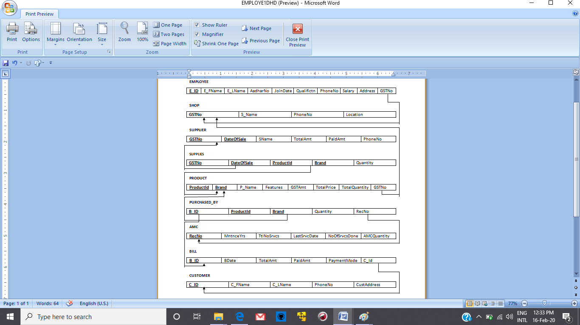

This table can be decomposed into

Supplier_Detail:

|  |  |  |
| --- | --- | --- |
| **GSTNo** | SName | PhoneNo |

Supplier_Transaction:

|  |  |  |  |  |
| --- | --- | --- | --- | --- |
| **GSTNo** | **DateOfSale** | TotalAmt | PaidAmt | PhoneNo |

By decomposition we get the above two tables. Now in the about two tables we don't have any transitivity between the attributes of the schema hence we can conclude that there cannot be for the decomposition of the tables.

Hence the Supplier relation is in 2NF and cannot be decomposed further into higher normal forms.

**Question 2:** Choose the **optimal** normalized schema from Question 1 and justify why you think this is an optimal solution.

We think that the normalized schema of Supplier is more Optimal compared to the de-normalized form as we can reduce the redundancy by keeping it in normalized form. Though we could not remove the redundancy completely but doing so we can remove most of the redundancy

**Question 3:** User Interface (UI) design

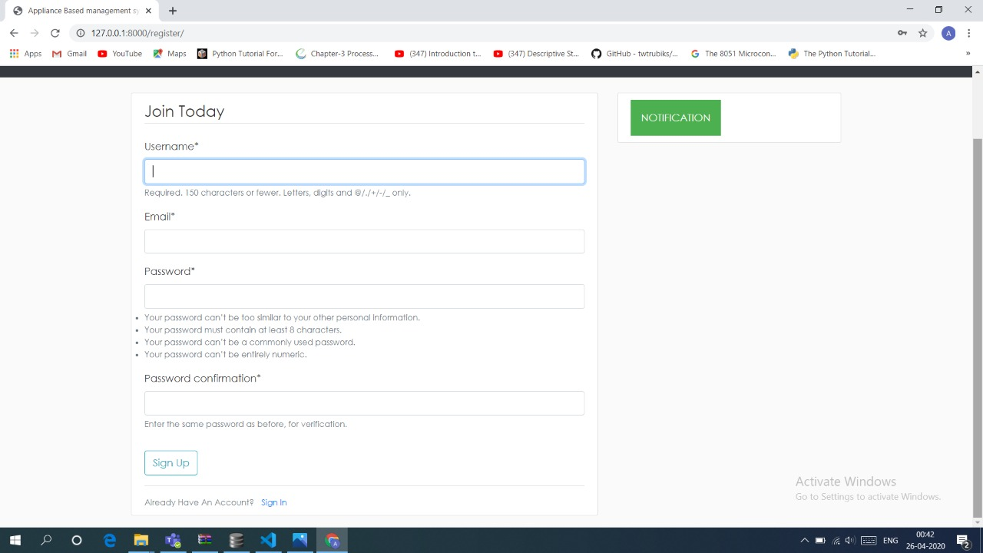 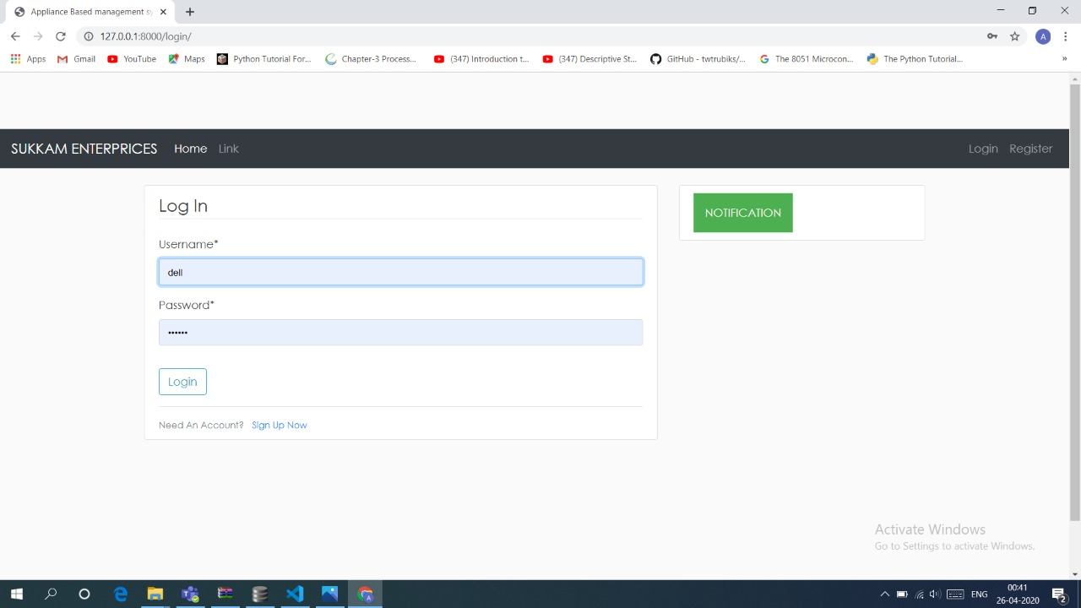 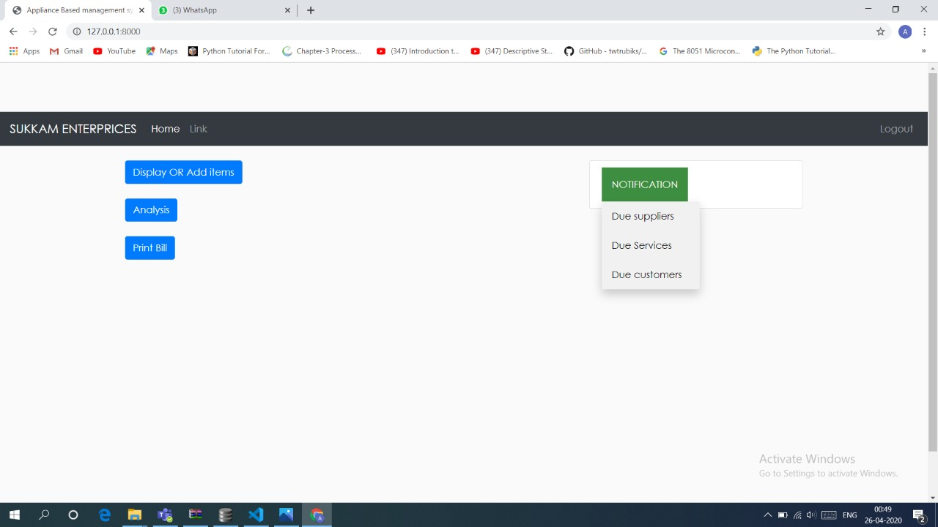

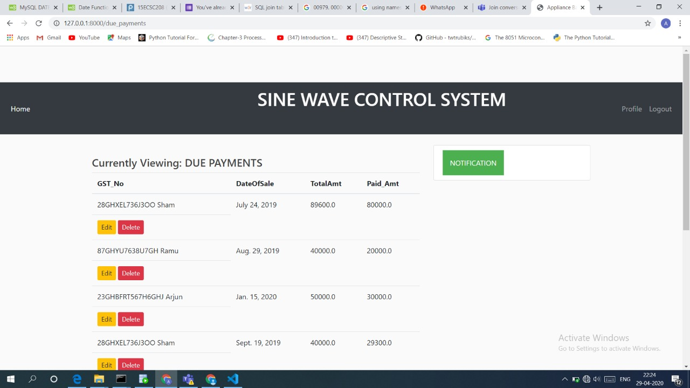

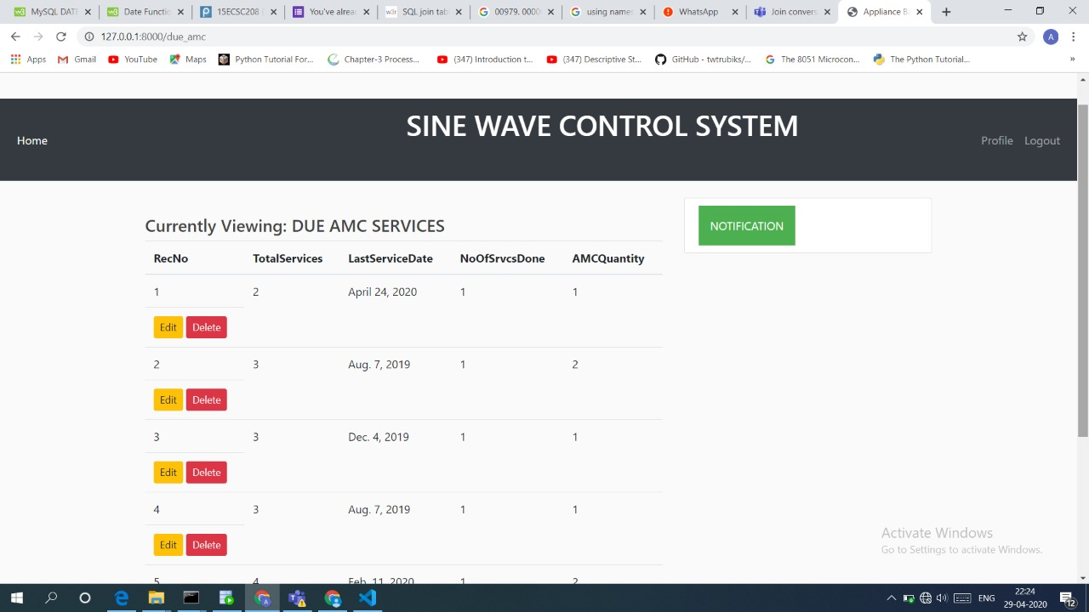

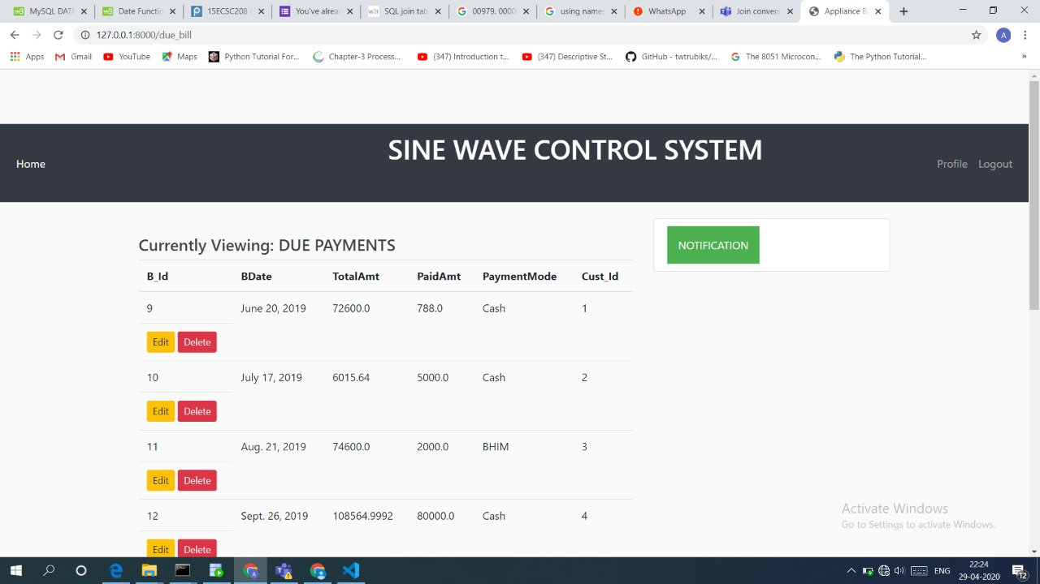

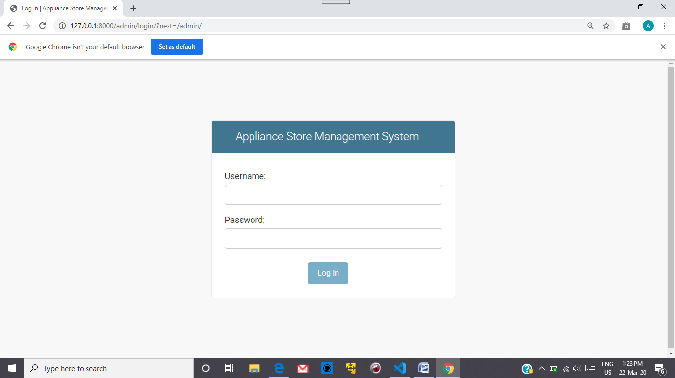

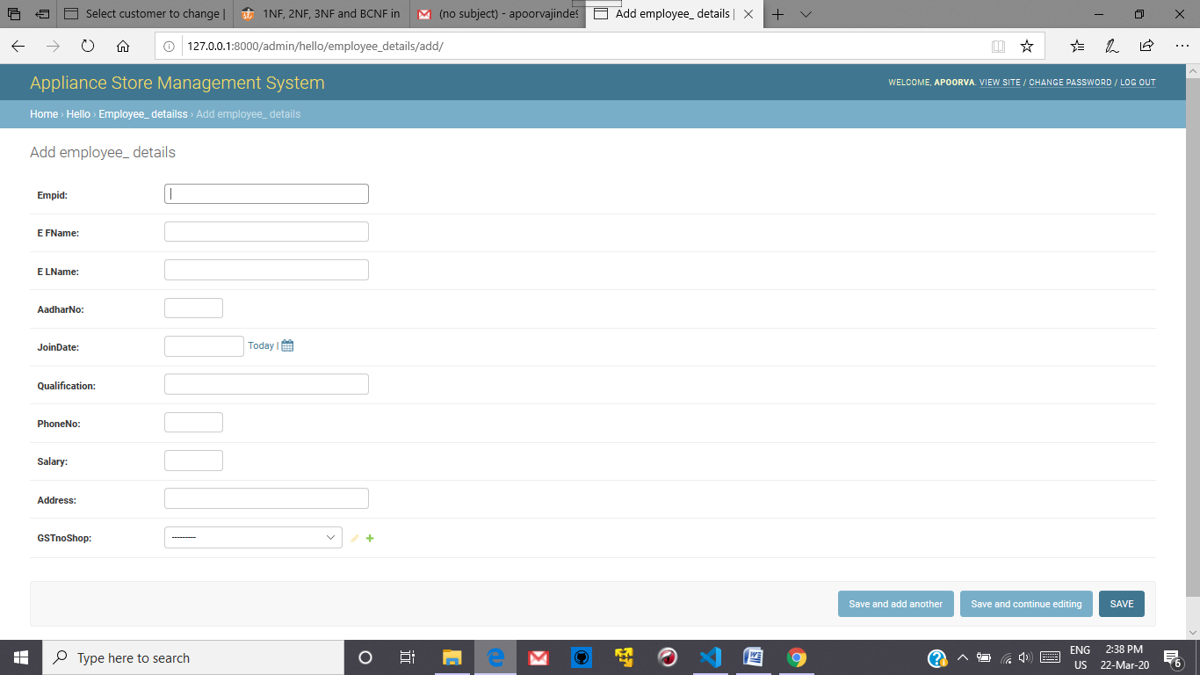

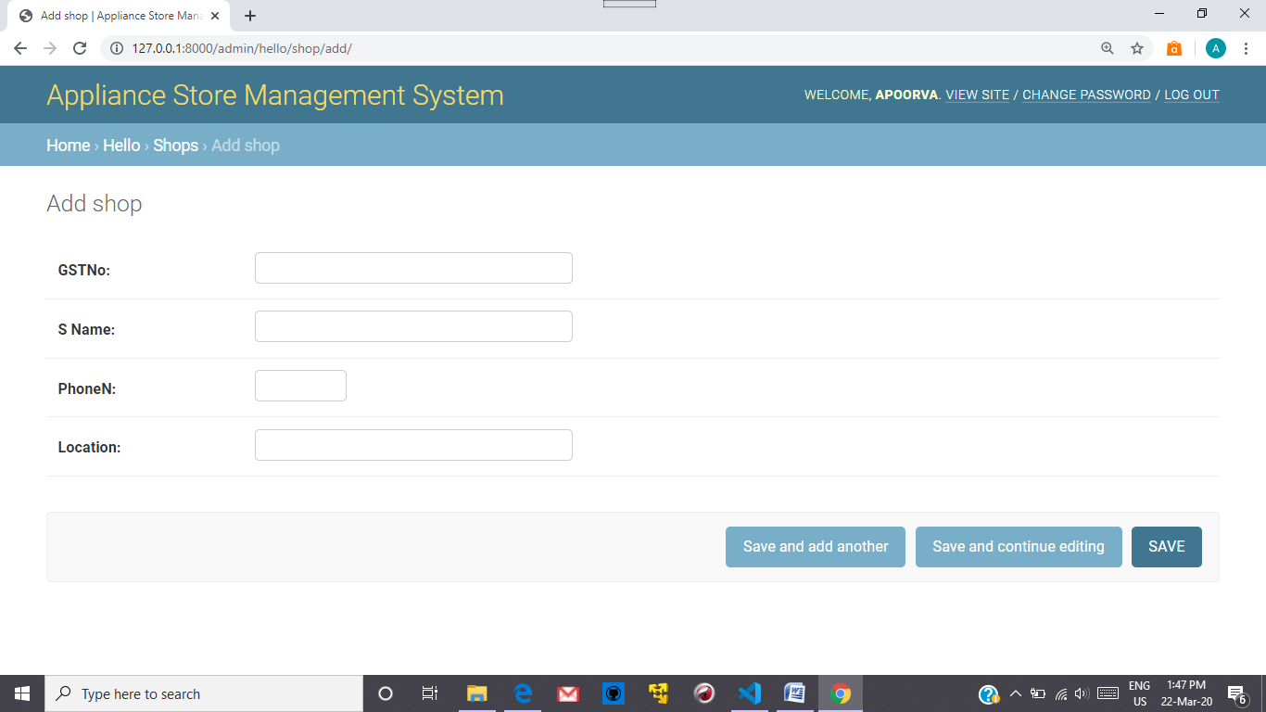

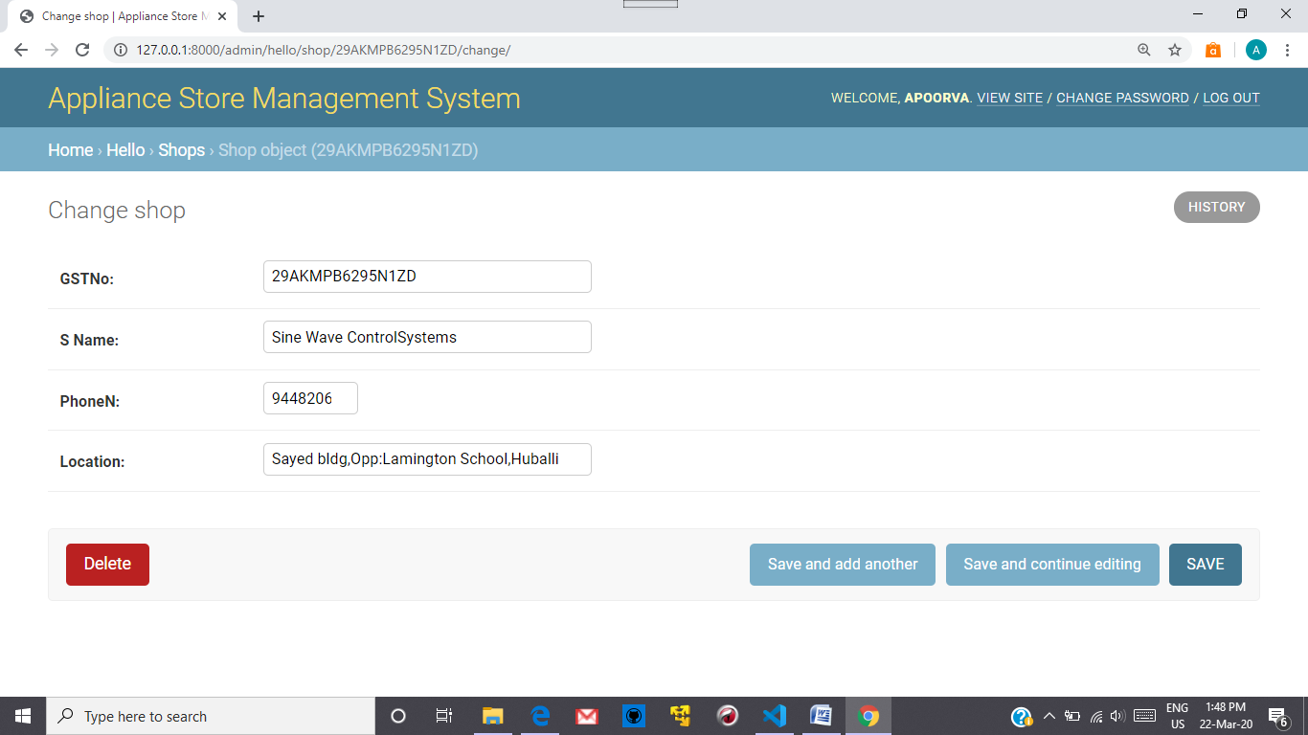

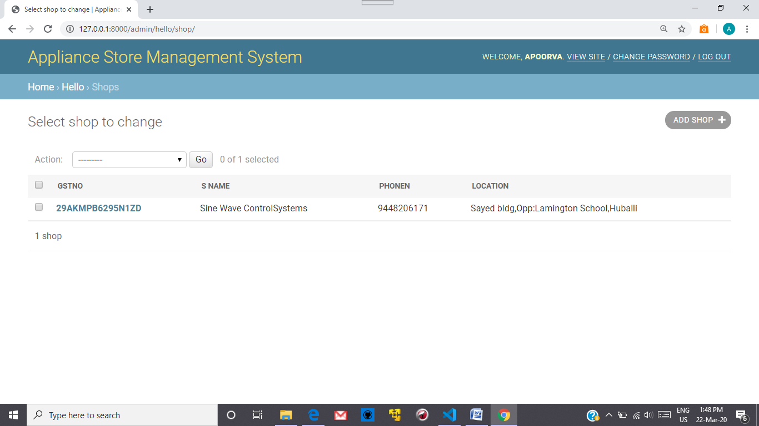 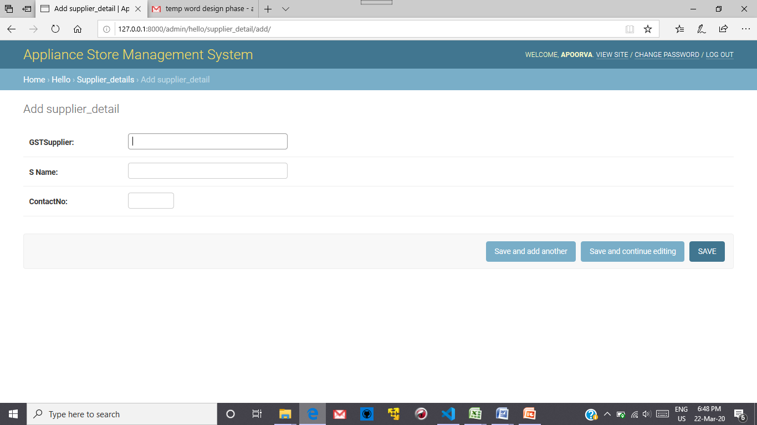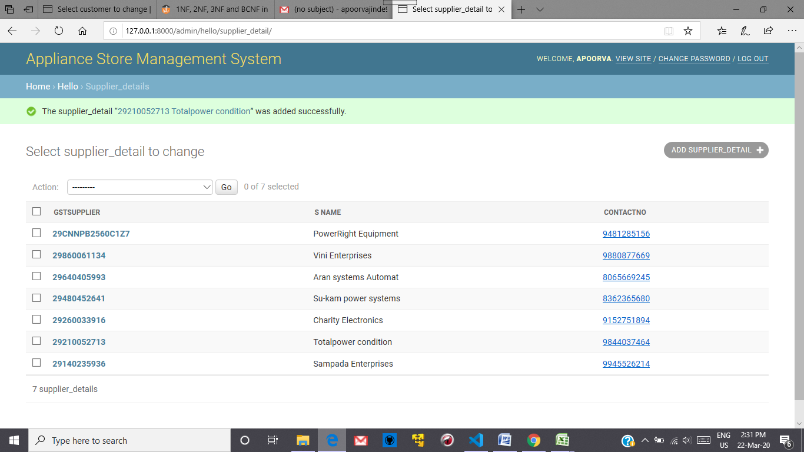

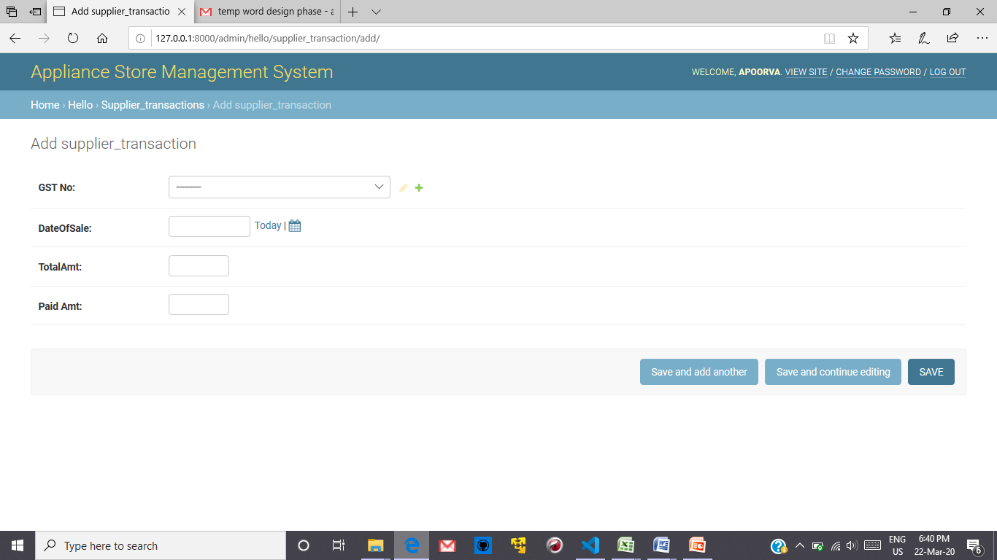 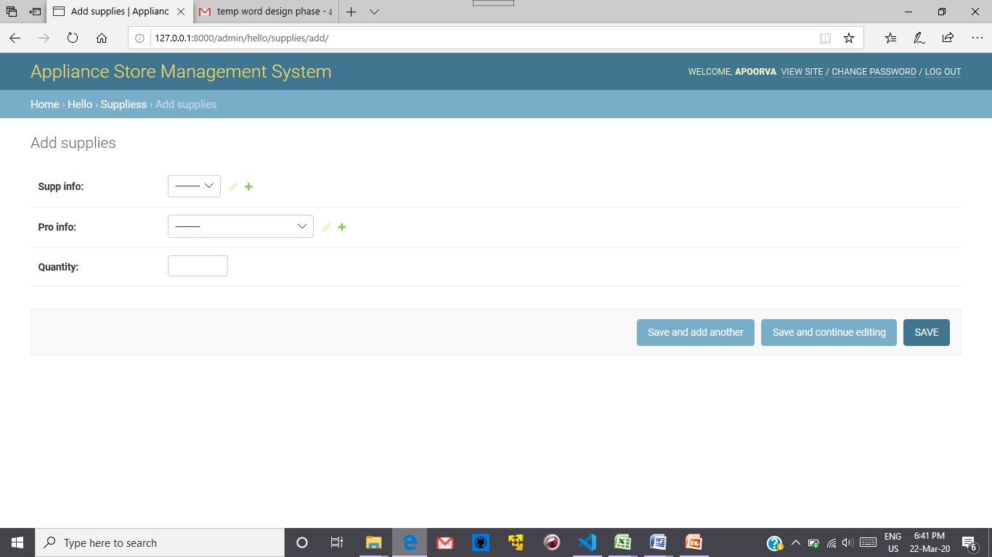 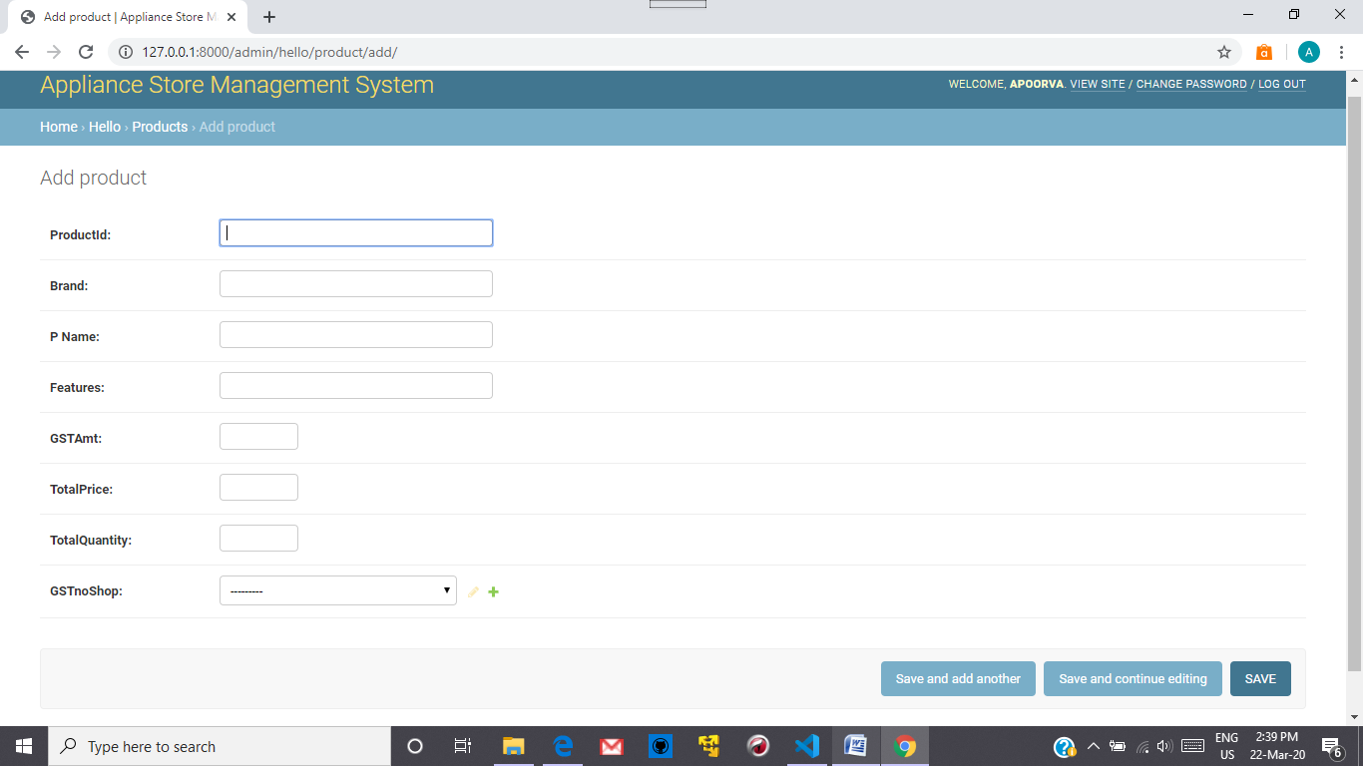 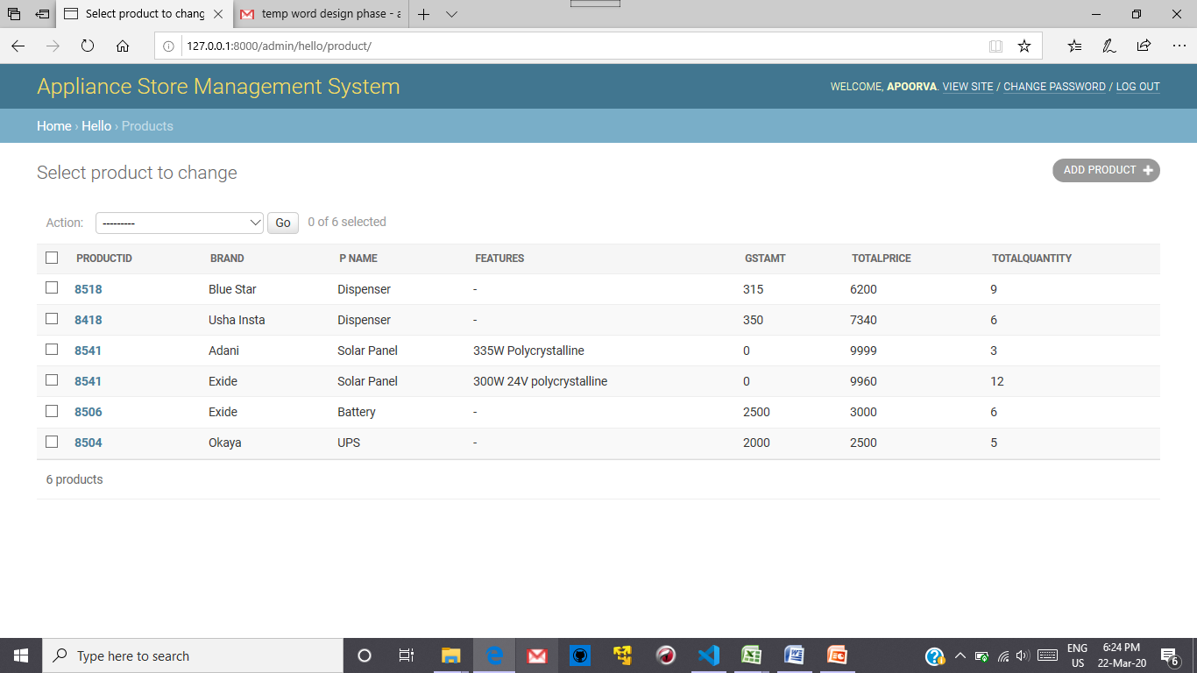 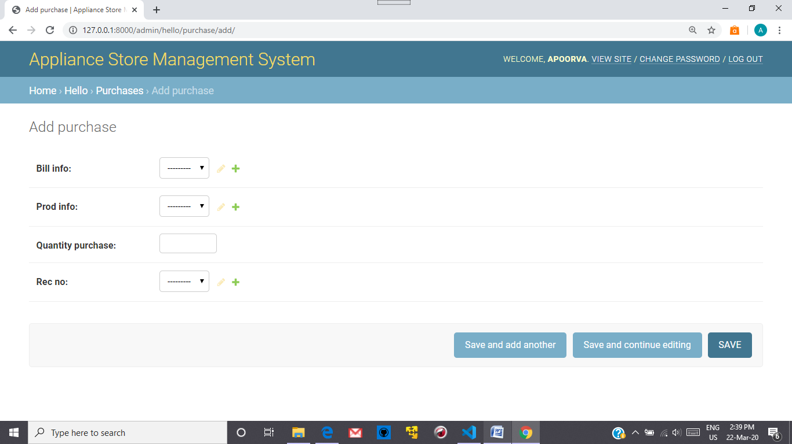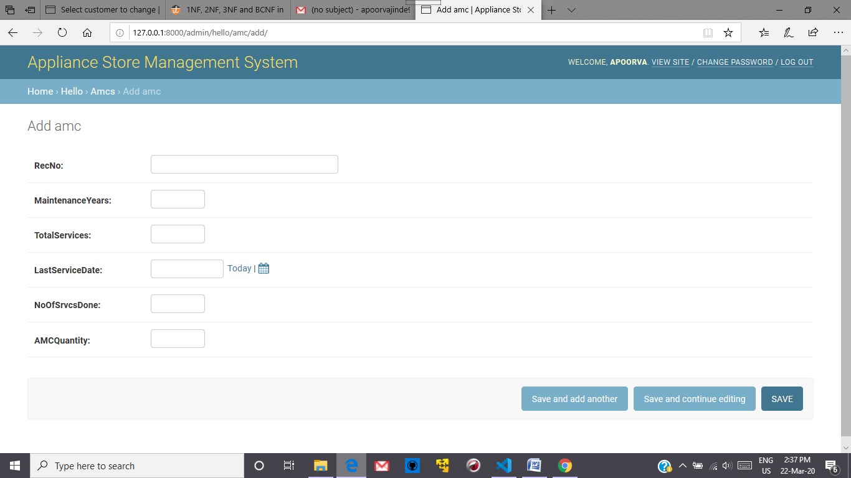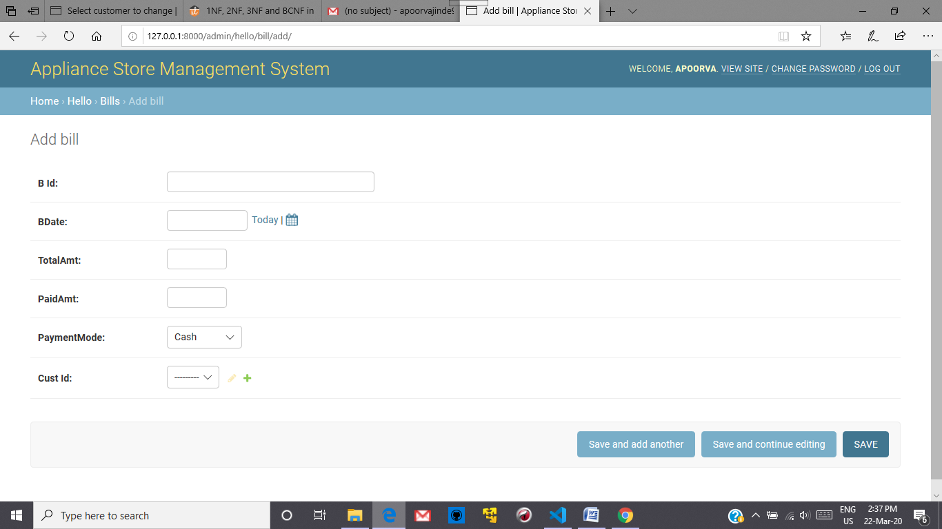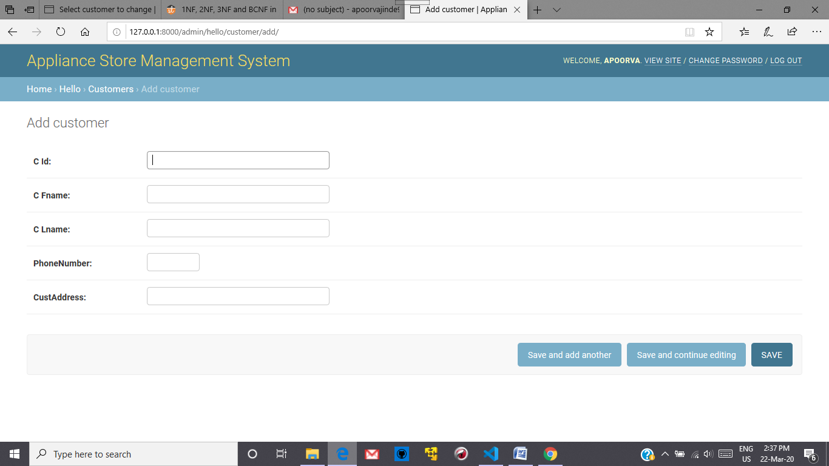 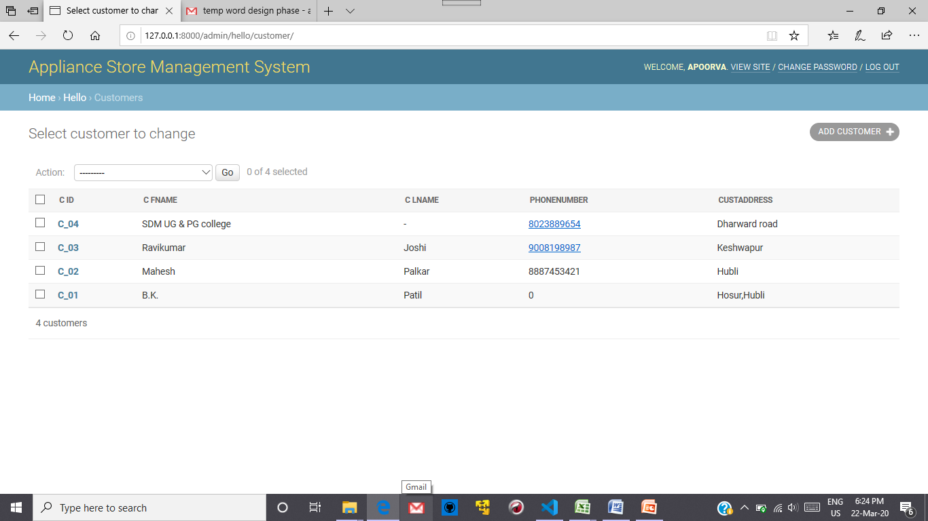

**Question 4:** Implemented requirements completed till date (if any)

1. Details about price of the product,Employees,Suppliers..

2. Details about Customer and their Accounts.

3. Proper security of all data.

**The requirement to be completed is** : Also make the necessary changes in the data dictionary as well in the implementation part where the user need not enter the IDs the UI should take care of the ID insertion .

**References: Django official documentation,GitHub**

**Submission Date: 28-03-2020**